Order Of Service

Singing: Psalm 148—CW page 121

Reading: Psalm 12

Opening Hymn: CW 260

Reading: I John 5

Request Hymn: CW Supplement 749

Reading: John 1:43-51

Sermon Hymn: CW 363

Sermon Text: Song Of Solomon 4:2

Her Teeth—Flock of Sheep

Prayer

The Apostles’ Creed, TLH page 12

Holy Communion

The Lord's Prayer

The Blessing

Closing Hymn: CW 505

* * * * * * * * * * *

Bible Study: Lambs: Ruth 1:16-17; Being Loyal
Sheep: Proverbs 10:19-20
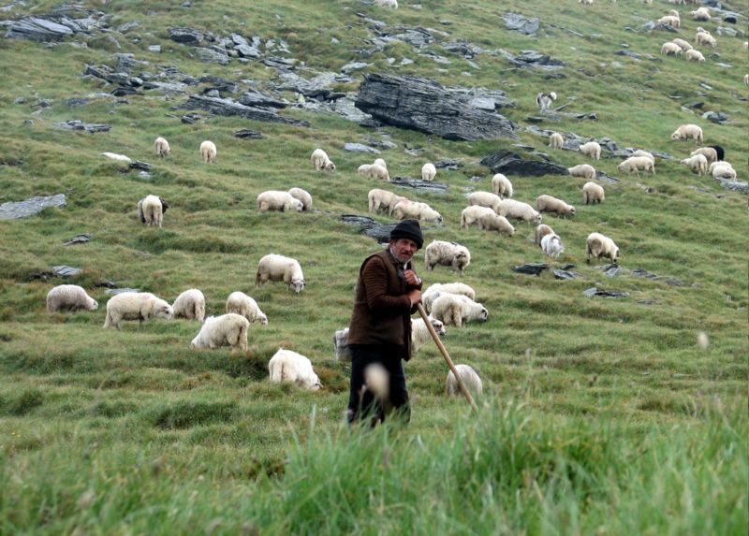

A Shepherd With His Flock

Water
Of
Life
17 July 2016

W A T E R O F L I F E

Independent Christian Church—Conservative Lutheran Doctrine

Worship Service: 9:30 a.m. Bible Study: 10:45 a.m.

Larry Cooper, Pastor E-Mail address:
111 N. Ridge Road lcooper@wateroflife.cc
Coon Valley, WI 54623 Web Site:
Phone: (608) 452-2105 www.wateroflife.cc

* * * * * * * * * * * * * * * * * * * * * * * * * * *

Sermon Text: Song Of Solomon 4:2

Her Teeth—Flock of Sheep

* * * * * * * * * * * * * * * * * * * * * * * * * * *

Song of Solomon 4:2 Thy teeth are like a flock of sheep that are even shorn, which came up from the washing; whereof every one bear twins, and none is barren among them.

Here in the opening verses of Song of Solomon chapter 4, we find the Bridegroom commenting upon the flawless beauty of his Bride.

The first thing he mentions is her beautiful eyes, which are compared to the eyes of doves. The second thing he mentions is her strikingly beautiful hair, which he compares to a flock of goats that appear from mount Gilead.
Now he turns his attention to her comely teeth, which he compares to a flock of sheep that are even shorn.

But there are teeth and there are teeth. In Scripture, the Holy Spirit writes of different kinds of teeth. To begin with, let’s turn the coin over and look at some evil teeth.



Children of the Devil are said to have lions’ teeth, and their teeth are compared to spears and arrows.

Psalm 57:4 My soul is among lions: and I lie even among them that are set on fire, even the sons of men, whose teeth are spears and arrows, and their tongue a sharp sword. One day soon their den will be located in the bottomless pit, where there will be the weeping and the gnashing of teeth.

In blessed contrast we have the Bride of Christ, whose teeth are like a flock of sheep that are even shorn, which came up from the washing; whereof every one bear twins, and none is barren among them.

